

Scotch College
Semester One Examination, 2010

Question/Answer Booklet

MATHEMATICS
3C/3D Specialist
Section One:
Calculator free

Teacher:
Mr Hill
Mr Robb

Name:

Time allowed for this section
Reading time before commencing work: 5 minutes
Working time for this section: 50 minutes

Material required/recommended for this section

To be provided by the supervisor
This Question/Answer Booklet
Formula Sheet

To be provided by the candidate
Standard items: pens, pencils, pencil sharpener, eraser, correction fluid, ruler, highlighters
Special items: nil

Important note to candidates
No other items may be used in this section of the examination. It is your responsibility to ensure that you do not have any unauthorised notes or other items of a non-personal nature in the examination room. If you have any unauthorised material with you, hand it to the supervisor before reading any further.

Structure of this paper

Section | Number of questions available | Number of questions to be answered | Working time (minutes) | Marks  available
Section One:  Calculator-free | 6 | 6 | 50 | 40
Section Two  Calculator-assumed | 12 | 12 | 100 | 80
 |  |  |  | 120

Instructions to candidates

1. The rules for the conduct of Western Australian external examinations are detailed in the Year 12 Information Handbook 2010. Sitting this examination implies that you agree to abide by these rules.

2. Write your answers in the spaces provided in this Question/Answer Booklet. Spare pages are included at the end of this booklet. They can be used for planning your responses and/or as additional space if required to continue an answer.
  - Planning: If you use the spare pages for planning, indicate this clearly at the top of the page.
  - Continuing an answer: If you need to use the space to continue an answer, indicate in the original answer space where the answer is continued, i.e. give the page number. Fill in the number of the question(s) that you are continuing to answer at the top of the page.

3. Show all your working clearly. Your working should be in sufficient detail to allow your answers to be checked readily and for marks to be awarded for reasoning. Incorrect answers given without supporting reasoning cannot be allocated any marks. For any question or part question worth more than two marks, valid working or justification is required to receive full marks. If you repeat an answer to any question, ensure that you cancel the answer you do not wish to have marked.

4. It is recommended that you do not use pencil except in diagrams.

Section One: Calculator-free (40 Marks)

This section has six (6) questions. Answer all questions. Write your answers in the space provided.
Spare pages are included at the end of this booklet. They can be used for planning your responses and/or as additional space if required to continue an answer.
  - Planning: If you use the spare pages for planning, indicate this clearly at the top of the page.
  - Continuing an answer: If you need to use the space to continue an answer, indicate in the original answer space where the answer is continued, i.e. give the page number. Fill in the number of the question(s) that you are continuing to answer at the top of the page.

Suggested working time for this section is 50 minutes.

1. [10 marks]

Given that 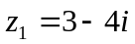 and 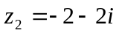, determine exactly:

(a) Im(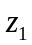+ 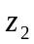) [1]

(b) 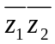 [2]

(c) 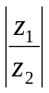 [3]

(d) the complex number k such that Im(k) = 2Re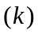-1 and k = 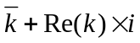. [4]

2. [8 marks]

Find  for each of the following, simplifying answers wherever possible

(a) 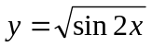 [2]

(b) 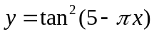 [3]

(c) 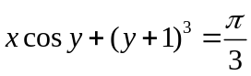 [3]

3. [5 marks]

Matrices A , B and C are all 2x2 matrices and 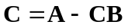

Determine C given that 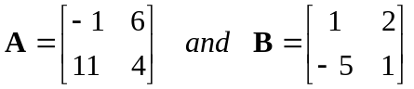

4. [4 marks]

Find the following indefinite integrals.

(a) 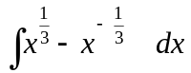 [2]

(b) 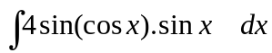 [2]

5. [5 marks]

Use proof by induction to prove that 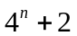is divisible by 3 for 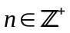.

6. [8 marks]
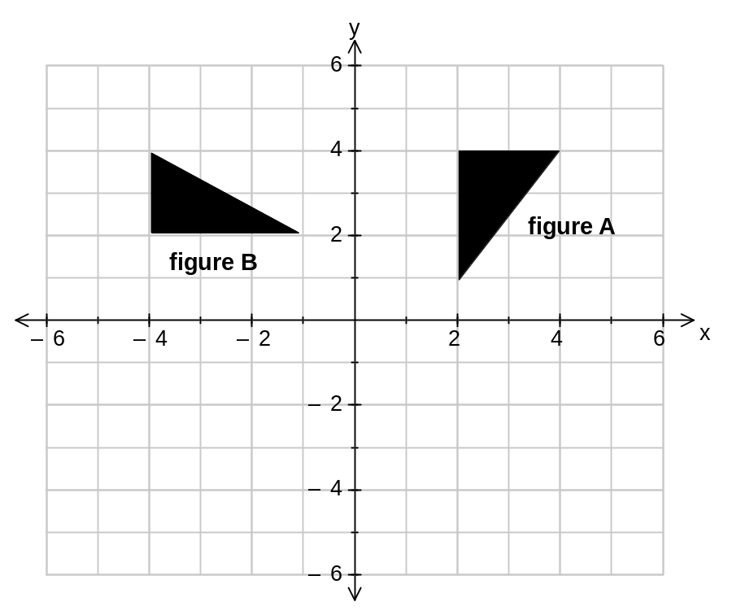

  - Write down the 2x2 transformation that would map the points from
figure A onto the points from figure B. [1]

  - Find a 2x2 matrix, T , that would firstly reflect figure B about the X axis and then transform this image onto a triangle with half the area of figure B. Draw the image on the grid above and label it figure C. [5]

(c) Find a single transformation matrix that will map figure A onto figure C. [2]

Additional working space

Question number(s):

Additional working space

Question number(s):

Additional working space

Question number(s):

Section 1 Question | Marks Available | Marks Achieved | Teacher Comments
1 | 10
2 | 8
3 | 5
4 | 4
5 | 5
6 | 8
Total Marks  Section 1 | 40
Section 2 Question | Marks Available | Marks Achieved | Teacher Comments
1 | 5
2 | 4
3 | 5
4 | 7
5 | 6
6 | 6
7 | 6
8 | 10
9 | 8
10 | 7
11 | 6
12 | 10
Total Marks  Section 2 | 80
Exam Total | 120

